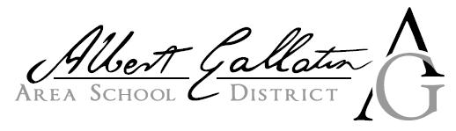
2625 Morgantown Road Uniontown, PA 15401 PHONE :(724)564-7190 FAX :(724)564-7195
Mr. Christopher A. Pegg, Superintendent
_____________________________________________________

August 23, 2021

Albert Gallatin Area School District & Community:

Based on all research regarding COVID-19 from the PA Department of Education (PDE), the US Department of Education (USDOE), the PA Department of Health (DOH), survey results, and in an effort to address learning loss due to the pandemic, the Albert Gallatin Area School District will be operating five (5) days per week utilizing a face-to-face / in-person instructional model for the 2021-2022 school year for all students. Students and parents not wanting their children in an in-person setting did have the option to enroll in our cyber program (COLA) for the start of the school year. The first day of classes for all students in Kindergarten, Sixth and Ninth Grades is Monday, August 30, 2021. Students in all other grades will start on Wednesday, September 1, 2021.

Please be certain that the Albert Gallatin Area School District continues to be diligent in cleaning, sanitizing & disinfecting all facilities on a daily basis. Our district takes pride in providing and maintaining a safe environment for all students, staff and visitors. We will continue to utilize air purifiers and electrostatic sprayers in all facilities in the district to help mitigate the spread of all germs.

Also, our buses will be disinfected in between runs each and every day in order to provide a safe environment during transportation, as well as being disinfected with the utilization of electrostatic sprayers on a weekly basis. Moreover, due to a Federal Mandate, all students and riders utilizing district transportation are required to wear a mask that covers their nose and mouth while on the bus or van.

According to the district’s approved Health and Safety Plan, the use of masks inside the school setting is highly recommended for all students, staff and visitors, but it is on a voluntary basis for staff and a parent choice for all students. As more information becomes available, we will keep all of you updated throughout the school year. For more information on our Health and Safety Plan and other important information, please visit our website at www.agasd.org. As always, we thank you for your support and look forward to the 2021-2022 school year!

Sincerely,
Christopher A. Pegg, Superintendent

