ALBERT GALLATIN HIGH SCHOOL ARMY JROTC RIBBON AWARDS
Medal for Heroism  Awarded to any JROTC Cadet who  performs an act of heroism | Superior Cadet  Awarded annually to one outstanding JROTC  Cadet in each LET level per school | Distinguished Cadet  N-1-1  Awarded annually to one cadet who exhibits the highest degree of expertise in scholastics | 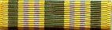  Academic Excellence  N-1-2  Awarded annually to one cadet in each LET level for maintaining highest school academic grades
  Academic Achievement  N-1-3  Awarded annually to those cadets  who maintain the grade of an A in all academic subjects |   Perfect Attendance  N-1-4  Awarded to cadets with no  unexcused absences during  each quarter/semester | 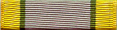  Student Government  N-1-5  Awarded annually to cadets elected  to any student government office | 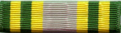  LET Service  N-1-6  Awarded to cadets successfully  completing the first quarter/semester  of training each LET year
S.A.I Academic  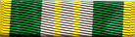  N-1-7  Awarded each semester to cadets who  maintain an overall average 3.5 GPA  and a “B+” or better in all academic subjects | 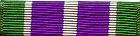  A.A.I. Academic  N-1-8  Awarded each semester to  cadets who maintain an overall  average 3.0 GPA and a “B-“  or better in all academic subjects |   Significant Contribution (ED)  N-1-9  Awarded to cadets who have made significant contributions to the Program over an extended period of time (e.g. service learning idea) | 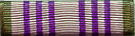  Significant Contribution (SD)  N-1-10  Awarded to cadets who made significant contributions to the Program over a short period of time (e.g. Large amount of Saber Donation)
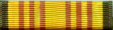  DAI/SAI Instructor Leadership  N-3-1  Awarded annually to one cadet per LET level who displays the highest degree leadership | 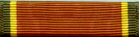  Personal Appearance  N-3-2  Awarded annually to cadets who consistently present an outstanding appearance |   Proficiency  N-3-3  Awarded annually to cadets who  have demonstrated leadership,  academic achievement, and performance | 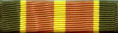  Drill Team  N-3-4  Awarded annually to drill team members
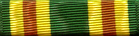  Orienteering  N-3-5  Awarded annually to cadets who  are members of orienteering teams |   Color Guard  N-3-6  Awarded annually to members  of the color/honor guard |   Rifle Team  N-3-7  Awarded annually to rifle team members |   Adventure Training  N-3-8  Awarded annually to cadets who are members of adventure training type units
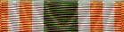  Commendation  N-3-9  Awarded to cadets  whose performance of duty exceptionally exceeds that of expected of a  cadet of his/her grade and experience |   Good Conduct  N-3-10  Awarded annually to cadets who have demonstrated outstanding  conduct throughout the school year | JCLC  N-3-11  Awarded to cadets for JCLC Participation | 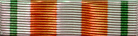  Exhibition  N-3-12  Awarded annually to members of Exhibition drill
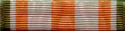  You Can Count On Me  N-3-13  Awarded to cadet that go above and beyond required participation | 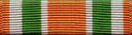  Academic/Leadership  N-3-14  Awarded to cadets who compete on either  the Academic or Leadership Team |   Honor Platoon  N-3-15  Awarded each semester to the  best platoon/period |   Varsity Athletics  N-2-1  Awarded annually to cadets  that excel in varsity sports
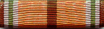  JROTC Physical Fitness  N-2-2  Awarded annually to cadets who score at or  above the 85 % on all five standard exercises |   JROTC Athletics  N-2-3  Awarded annually to cadets who score  at or above 50 % on all five standard exercises |   Raider Team  N-2-4  Awarded annually to members of raiders |   Optional by SAI  N-2-5
  Parade  N-4-1  Awarded to cadets who participated  in a parade as part of a JROTC unit |   Recruiting  N-4-2  Awarded to cadets who recruit at  least 2 students to JROTC  and for each student thereafter | 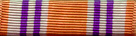  Positive Mental Attitude  N-4-3  Awarded each semester to active P.M.A.  team members and who promote  motivation within the Program | 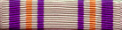  Booster  N-4-4  Awarded to cadets who attend  any two: Final Review, Formal  Inspection, or District Inspection
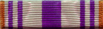  Community Service  N-4-5  Awarded to cadets who actively  participate in community service | Service Learning  N-4-6  Awarded annually to cadets who  participate in service learning projects | Excellent Staff Performance  N-4-7  Awarded annually to cadet staff  officers for excellent performance

