JCLC Keystone 2013 – ALBERT GALLATIN COLONIAL BATTALION

MEMORANDUM OF INSTRUCTION FOR JCLC Keystone Participants

TO: Parents/Guardians

FROM: SFC Harmon

SUBJECT: JCLC Keystone 2013 – Boswell, PA

DATE: May 3, 2013

- COMMANDER’S INTENT: To conduct JROTC Cadet Leadership Challenge (JCLC) Keystone 2013 at Outdoor Odyssey, Boswell, PA on 2-4 June 2013.

2. OBJECTIVES: The objectives of the Camp Commander at JCLC Keystone 2013 are:

a. To provide a safe, healthy and fun training environment that is both physically and mentally challenging.
- To provide hands-on training designed to develop leadership, discipline, teamwork and self-confidence.
- To provide adventure training not normally available on campus.
- Enable cadets to practice leadership in a challenging environment.
- Allow cadets to participate in citizenship-building exercises.
- To give cadets the opportunity to experience living and interacting with their peers in a military setting.
- To take advantage of recreational facilities available in the area and to have fun.

- CADET RESPONSIBILITIES:

  - Cadets must be in excellent physical condition and meet the haircut and grooming standards IAW CCR 145-14.
  - Cadets under a physician’s care, in a cast, with an allergy, pregnant, with asthma, diabetes, sickle cell anemia, epilepsy, STD, or other debilitating condition not specifically addressed will not be allowed to attend JCLC.
  - Cadets must return completed enrollment packets and medical forms by Friday, May 24th for review by SFC Harmon
  - Cadets will be issued boots once enrollment packet is complete and reviewed. (Boots need to be broken in prior to arrival at JCLC.)
  - Cadets must be prepared to assume leadership positions at JCLC (at the minimum, squad leader).
  - Each cadet and their baggage will be inspected for contraband items i.e. knives, handcuffs, martial arts devices, mace dispensers, tobacco products, non-prescription drugs, drug paraphernalia, alcohol, or pornographic material, electronic devices, or cell phones just prior to departure to JCLC and again at Camp.
  - Cadets will be exposed to a military lifestyle at JCLC to include: Drill and Ceremony, Leadership, Rappelling, Orienteering, Physical Fitness, and Land Navigation.
h. Chain of command must be followed. There will be six schools attending and cadets will be divided into three platoons and may not be directly under the supervision of SFC Harmon.

- CADET ADMINISTRATIVE REQUIREMENTS: Complete cadet enrollment packets
(Encl 1-7). Enrollment packets will consist of the following items:

      - JCLC In/Out Processing Form. Fill in cadet information and emergency contact information. Leave Unit of Assignment, and dates of in and out processing blank.
      - CC Form 145-14-2R (Covenant not to Sue). If the parent refuses to sign, the cadet cannot attend JCLC.
c. Outdoor Odyssey Release of Liability. Signed by parent/guardian. This form must be filed with JCLC Commander upon arrival at camp.
- Outdoor Odyssey Health Form. Signed by parent/guardian and witnessed by SAI/AI. This form must be filed with JCLC Commander upon arrival at camp.
- Health and Physical Fitness Statement. Signed by parent/guardian and SAI/AI on each cadet selected to attend summer camp. SAI/AIs are required to screen cadet records prior to the start of camp to ensure compliance with this MOI.
- Cadet Discipline contract. Signed by parent/guardian and witnessed by SAI/AI.
- Clothing and Equipment Checklist

5. APPEARANCE STANDARDS

  - Cadre and cadet appearance standards must be IAW CC Reg 145-14 and AR 145-2. The uniform for cadets is the Army Combat Uniform (ACU). Any cadet not in compliance with standards of CC Reg 145-14 and AR 145-2 could be considered for early release from JCLC.
  - Male Cadets.
    - Uniforms should be properly fitted. The hair will be neatly groomed as not to present a ragged, unkempt appearance. Hair may present a tapered or blocked appearance and when combed will not fall over the ears or eyebrows or touch the collar except for the closely cut hair at the back of the neck. The bulk or length of the hair will not interfere with the normal wear of military headgear.
    - If the individual desires to wear sideburns, they will be neatly trimmed. The base of the sideburns will not be flared and will be clean at the horizontal lines. Sideburns will not extend downward beyond the lowest part of the exterior ear opening.
    - The face will be cleanly shaven, except that a mustache is permitted. If a mustache is worn it will be kept neatly trimmed, tapered and will not present a chopped off appearance. No portion of the mustache will cover the upper lip line or extend horizontally beyond or below the corner points of the mouth, where the upper and lower lips join. Handle bar mustaches, goatees and beards are not authorized.
    - Male personnel are not authorized to wear any jewelry or other objects affixed directly to their body. This restriction does not include watches or rings.
  - Female cadets.
    - Bulk, style or length of hair will not interfere with wearing of military headgear. Hair will be groomed and will not present an extreme, ragged, or unkempt appearance.
    - Hair will not extend below the bottom edge of the collar, nor be cut so short as to appear unfeminine. Hair holding ornaments (e.g. barrettes, pins and clips) must be natural color and be inconspicuously placed.
    - Hair colors will be non-extreme and of natural shades. Make up and nail polish will be conservative and complement the uniform.
    - Female cadets are not authorized to wear any jewelry or other objects that are affixed directly to their body while in the ACU. This restriction does not include watches or rings.

  - Male and female cadets: The wearing of a wristwatch, identification wrist bracelet and no more than two rings are authorized with the Army uniform as long as the style is conservative and in good taste. The wearing of a purely religious medal on a chain around the neck is authorized provided neither the medal nor the chain is exposed. Cadets should be encouraged not to wear rings or expensive watches during training; they can be safety hazards and/or damaged.

6. DISCIPLINE, LAW AND ORDER.

  - The JCLC Commander has the authority to dismiss cadets, cadre and chaperons for misconduct or failure to comply with JCLC policies.
  - Cadets will be assigned a platoon, a cadet chain of command will be established, and cadets will be assigned a bunk in the cabin. Each platoon will establish a platoon Motto, and cadets will move in an orderly manner by platoon to all sites. If a cadet has an emergency during JCLC, the SAI or AI must be notified as soon as possible so as to determine the cadet’s disposition.
  - Cadets will not consume alcohol or use tobacco products at any time. Cadets will maintain cleanliness and maintenance of the cabin, keep perishable food out of the cabin, ensure lights are out NLT 2200 hrs, secure all valuables, and use buddy system at all times.
  - Drugs and Medication. No drugs of any type will be consumed by or permitted in possession of cadre, chaperons or cadets at JCLC, except those prescribed by a physician. Prescribed drugs will be screened by medical personnel during in-processing and their use will be controlled and administered by their SAI/AI.
  - Early Dismissal of Cadets from JCLC. If a cadet is required to leave camp early, it is the sole responsibility of the school representative to make whatever arrangements necessary for prompt transportation for the cadet. The school representative should make every effort to encourage the cadet’s parent/guardian to pick the cadet up from JCLC.
  - The following is a list (not all inclusive) of offenses considered to be a major infraction of good order and discipline, and for which punishment will be dismissal from camp.
    - Consumption of or possession of alcoholic beverages, drugs, or tobacco products.
    - Possession of ammunition of any type at any time to include ammunition residue and empty shell casings.
    - Unauthorized absence, including bed check.
    - Willful disobedience of authorized orders.
    - Fighting.
    - Possession of weapon of any type.
    - Shoplifting, including larceny or burglary of any type.
    - Unauthorized fraternization or sexual promiscuity.
    - Use of cell phone or electronic devices.
  - Enforcement of the “expulsion rule” will be strictly adhered to for any of the above infractions. Cadets will not leave the JCLC area without the JCLC Commander’s approval. It is the responsibility of the school representative to ensure the Camp Commander is informed before the cadet leaves camp.
  - Cadet Chain of Command for issues/discipline/medical problems will be: Cadet Chain of Command, Camp Counselor, Platoon TAC, SAI/AI, and Camp Commander.

      - ADDITIONAL INSTRUCTIONS.
- The buddy system must be used at all times during JCLC.
- Cadets with a history of heat injuries and allergies to insect bites/stings must notify the SAI/AI prior to JCLC and the information will be given to the Camp Commander.
- Cadets will bring their luggage to school on Friday, May 31st except for any personal hygiene items that they might need until Sunday morning. All luggage will be checked for contraband items. Cadets will repack at the school on Friday, and place all items in their assigned duffle bag. Cadets will leave directly from school Sunday, June 2nd at 7:30 a.m. and return approximately at 5:30 p.m. on Tuesday, June 4th.
- Cadets are not permitted to bring cell phones or any other electronic devices with them to camp.
- Parents will be required to pick up cadets at the school when they return late Tuesday afternoon.
- JCLC Emergency Phone Number: 1-814-629-6516

Enclosures:
JCLC In/Out Processing Form, CCR 145-2
CC Form 145-14-2R, Covenant not to Sue
Outdoor Odyssey Release of Liability.
Outdoor Odyssey Health Form.
Health and Physical Fitness Statement.
Cadet Discipline contract.
Clothing and Equipment Checklist

JCLC IN/OUT PROCESSING

Last name, First, MI: _______________________________________ SSN: _______________ Address: ______________________________________________________________________
City: _____________________________ State: __________ Zip Code: ___________________
School: Albert Gallatin Area High School Let Level: __________________ DOB: ___________________________________

Person to be notified in case of emergency:
Name and relationship: _________________________________________________________ Address: ___________________________________________ City: ____________________ State: _______________________________ Zip Code: ____________________

- - - -- - - - - - - - - - - (Information below will be completed at Camp) - - - - - - - - - - - - - - - - - -

Unit of Assignment:
Company: _________________________ Platoon: ____________________ Squad: ______ Cadre Institutional Representative: ________________________________________________

Date In-processed: ______________________
Date Out-processed: _____________________
Covenant Not to Sue for JCLC on File: __________
Special Power of Attorney on File (as needed): __________

COVENANT NOT TO SUE
OFF-CAMPUS TRAINING AND PRACTICAL FIELD/HIGH RISK TRAINING

(1) AUTHORITY: Title 10, U.S. Code 23-1.
(2) PRINCIPAL PURPOSE(S): To release the U.S. Government, the host institution and the state in
which said institution is located from liability for injury; death, or damages for JROTC cadets
participating in voluntary off-campus training programs, practical field, and high risk training.
(3) ROUTINE USES: Normal personnel actions. Disclosures of information may be provided to proper
authorities in actions regarding law enforcement, legal actions as a result of injury or death, and
investigations of accidents resulting from such voluntary off-campus training, practical field, and highrisk
training.
(4) MANDATORY OR VOLUNTARY DISCLOSURE AND EFFECT ON INDIVIDUAL NOT
PROVIDING INFORMATION: Voluntary. Failure to complete form will disqualify JROTC cadet
from participating in specific voluntary training exercises.

I_______________________________, residing at_______________________,_____________
(Type or print full name) (Address) (City)

do hereby agree that in consideration for being allowed to participate in JCLC,

conducted by ______________________________ Army JROTC detachment, and Army
(Name of JROTC Instructor Group)

supervised activity, and whereas I am doing so entirely on my own initiative, risk, and responsibility; and
being fully aware of the risk adhering to this type of training, I hereby RELEASE AND DISCHAGE
FOREVER, the United States Army, the State of Pennsylvania and Albert Gallatin Area SD and all of
its officers, agents, and employees, acting officially or (Name of School)

from any and all claims demands, actions or causes of action, on account of myself OR on account of any
injury to me which may occur from any cause during said activity or continuances thereof, and I do
further covenant and agree to hold the said Government of the United States, State of __________,_____

_____________and all of its officers, agents, and employees, acting officially or otherwise, blameless for
any and all damages which I may cause either intentionally or thru my negligence.

___________________________________ ___________________________________
Typed/Printed Name of Parent or Guardian if Signature of Parent or Guardian if
Participant is a Minor Participant is a Minor

___________________________________ ___________________________________
Relationship to Cadet Date

WITNESSED BY:
____________________________________
Age/Period Covered

____________________________________
Signature of Cadet

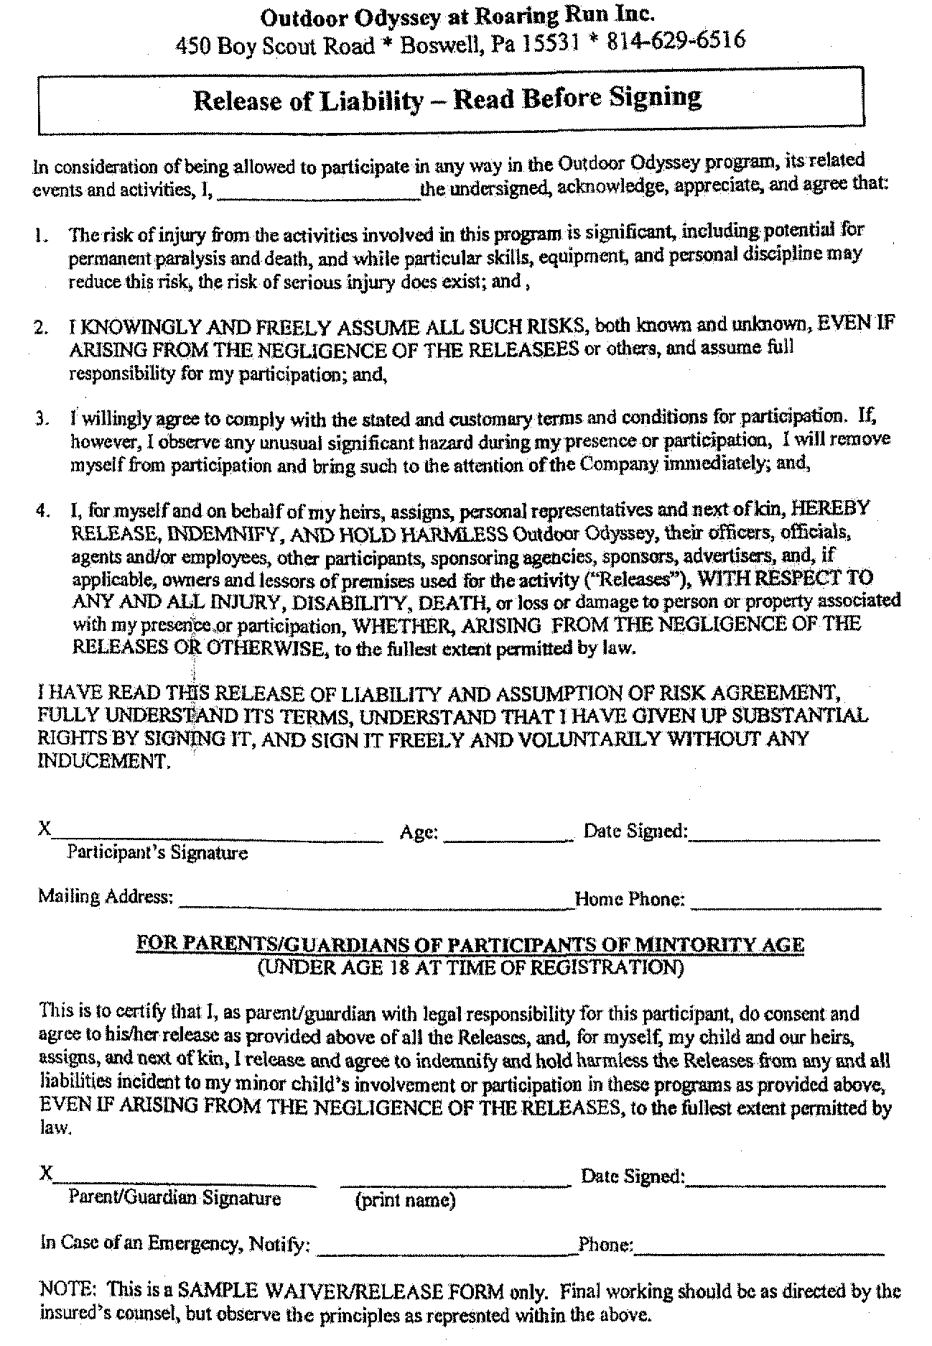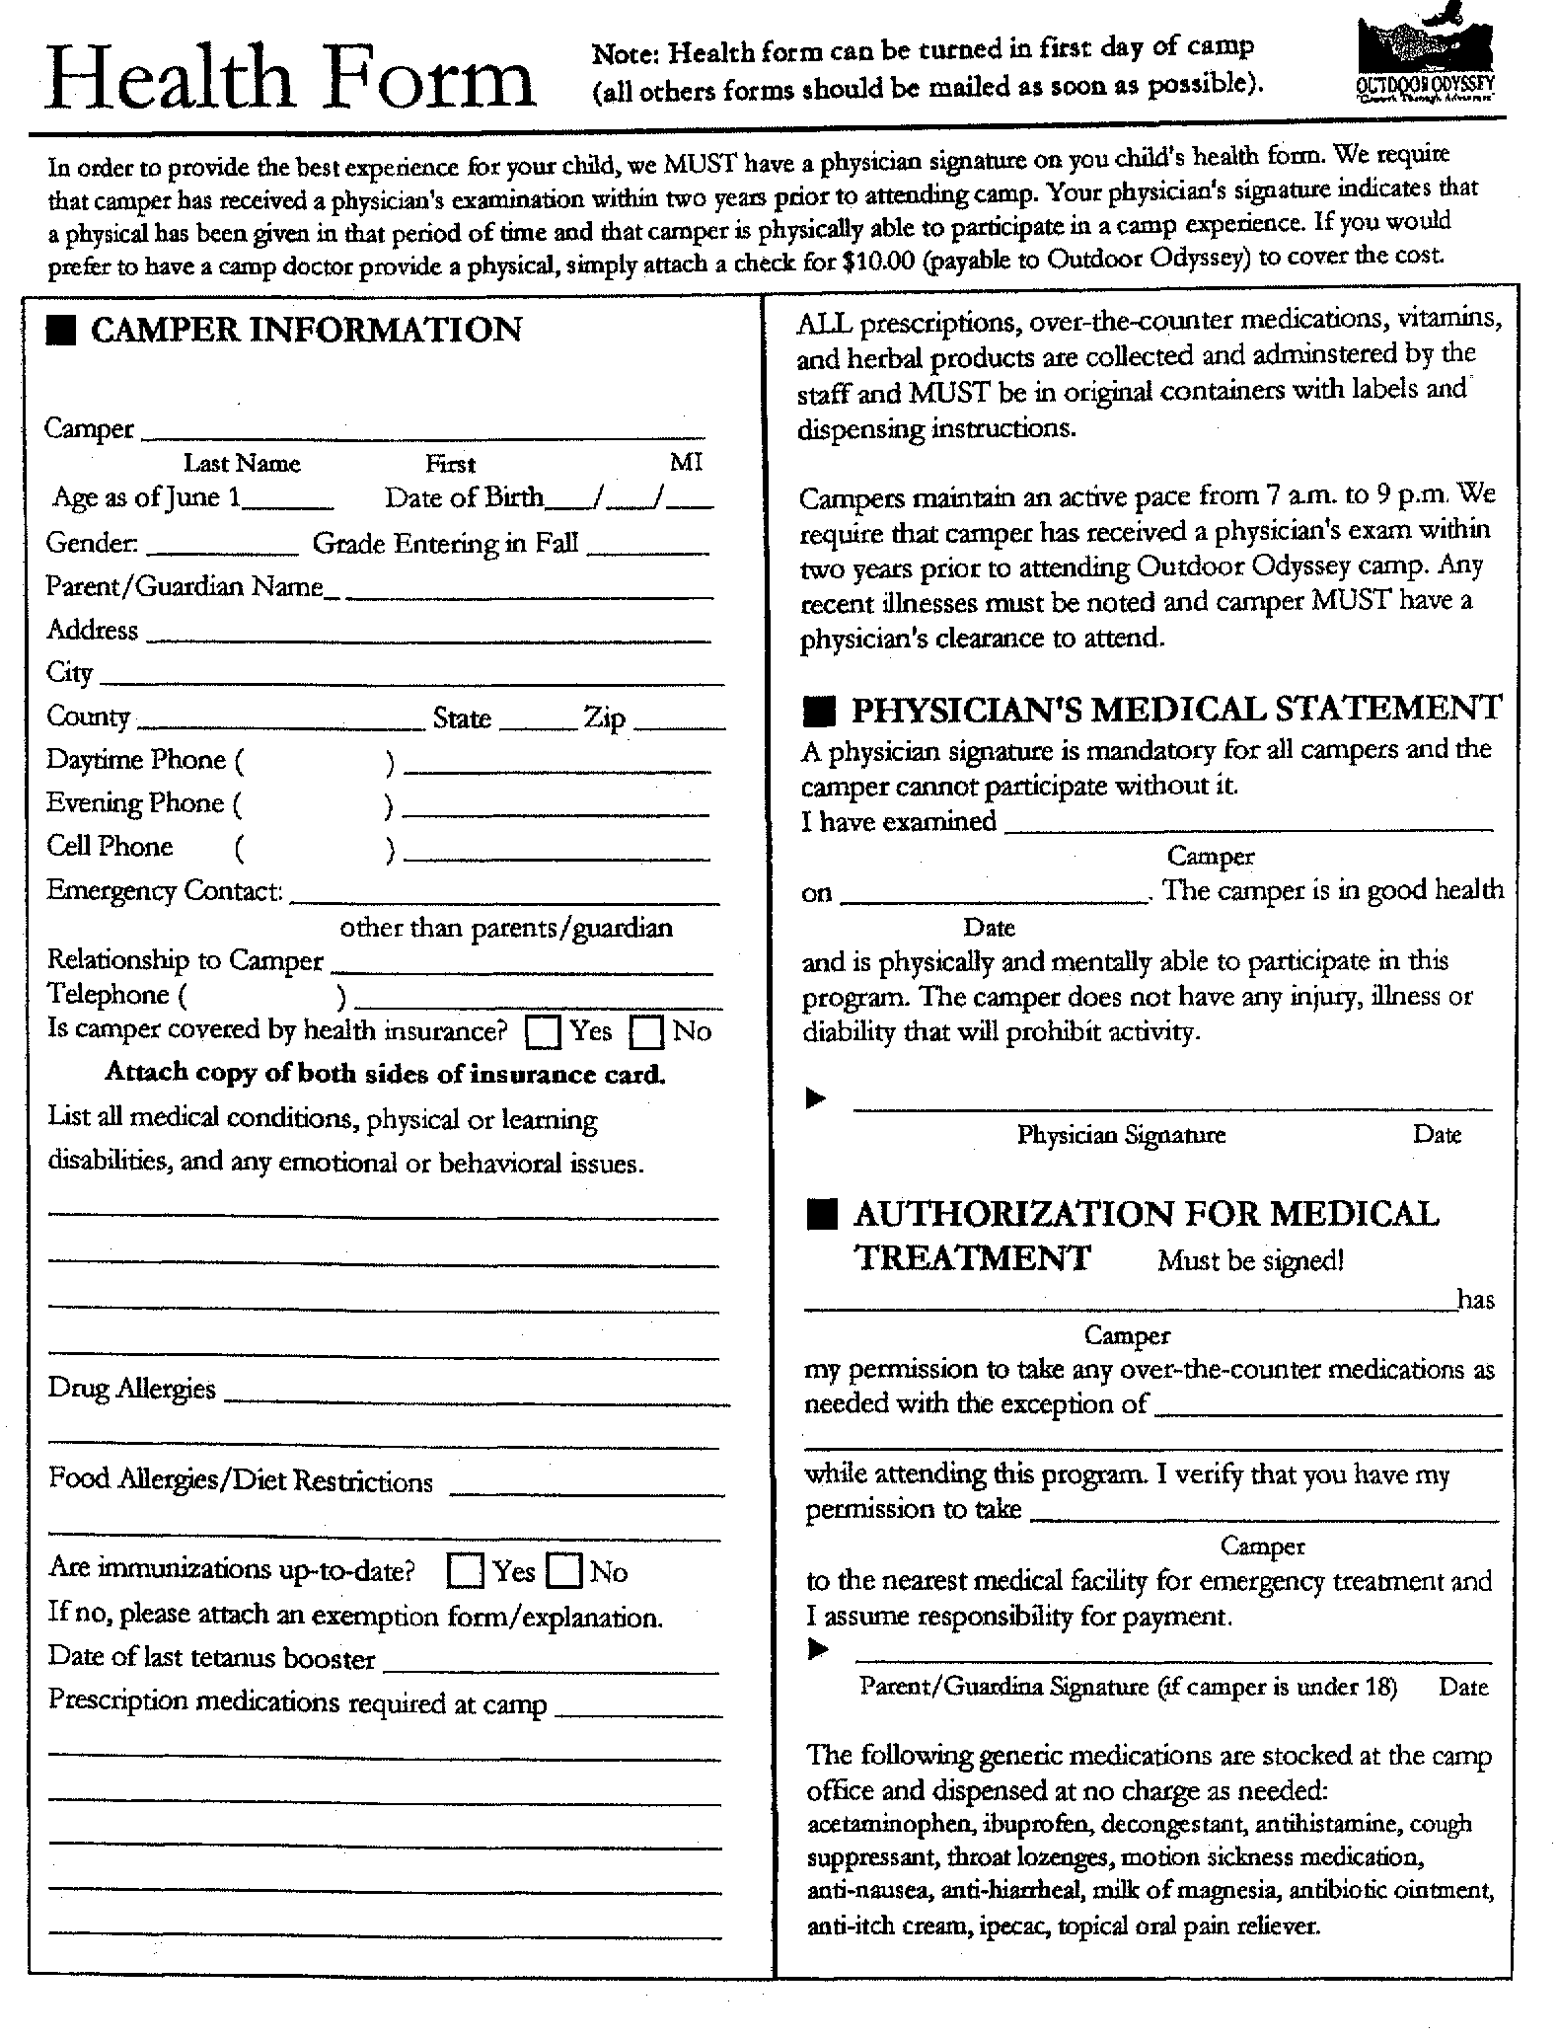

HEALTH AND FITNESS STATEMENT

HEALTH STATEMENT

I understand JCLC Keystone West will be a strenuous and physically demanding period. I certify that Cadet______________________________ is in good health and has no medical restrictions (i.e. allergy; asthma; bone fractures; respiratory condition; blood, heart or kidney disorders; pregnancy; epilepsy; diabetes; sickle cell anemia; or venereal diseases) or any physical or mental disorder that would cause hardship or endanger their well-being.

SIGNATURE/DATE____________________________________________
(Parent/Guardian)

PHYSICAL FITNESS STATEMENT

I certify that the above named cadet has taken part in a physical conditioning program and has achieved at least a 50 percentile score on the Cadet Challenge. I am responsible for returning the cadet home, expeditiously, in the event the cadet is not physically fit. In my judgement, this cadet is physically capable of engaging in the strenuous activities required at JCLC. To the best of my knowledge, this cadet has no health problems that would preclude attendance at JCLC.

SIGNATURE/DATE____________________________________________
(SAI/AI)

CADET DISCIPLINE CONTRACT

I, Cadet ___________________, enrolled in JROTC at Albert Gallatin Area High School, have been briefed about JROTC Cadet Leadership Challenge (JCLC) Keystone West. I realize that the purpose of the JCLC is to provide me with a challenging, meaningful, and hands-on training experience, in a military environment, which develops good citizenship, patriotism, and leadership techniques. I hereby volunteer to fully participate.

I have been informed of, and am fully aware of the standards of behavior and performance that I will be expected to maintain while at JCLC. I understand my JCLC role as a cadet engaged in intense citizenship and leadership training through followership positions. I realize the importance of DISCIPLINE, RESPECT and COURTESY and that the JCLC standard is very high, but attainable.

I pledge that I will always do my best at JCLC Odyssey, attempt to accomplish all that is asked of me to the best of my ability, and always obey JCLC rules. I accept JCLC disciplinary action, through the JCLC Commander. I acknowledge that the JCLC Commander has the final and ultimate authority to disenroll and release me from JCLC should my behavior and/or performance warrant. Dismissal will result in my early departure from JCLC and subsequent return home, at personal expense. (Please note that refunds of JCLC monies are not authorized.)

In the event of any serious problems that develop, with regard to the letter and intent of this contract, the JCLC staff and cadet’s SAI/AI will make every attempt to contact the cadet’s parent/guardian. In the event that the JCLC Commander determines that the dismissal from JCLC is required, the cadet’s parent/guardian will be responsible to immediately retrieve their child from JCLC at their personal expense.

Additionally, from an administrative standpoint, I realize that there are several administrative actions that may result in my early dismissal from JCLC. These are: submitting an incomplete and/or inaccurate JCLC forms packet upon in-processing on arrival, and or failure to meet high standards of appearance upon arrival at JCLC. Failure to resolve these shortcomings by the first event is cause for JCLC disenrollment the following morning.

SIGNATURE/DATE: _________________________________________________
(Cadet)

SIGNATURE/DATE: _________________________________________________
(Parent/Guardian)

Printed Name:________________________________________________________
(Parent/Guardian)

SIGNATURE/DATE: _________________________________________________
(SAI/AI)

JCLC KEYSTONE WEST
OUTDOOR ODYSSEY, BOSWELL, PENNSYLVANIA

Clothing and Equipment Checklist

The below listed items of clothing and equipment are required for attendance at JCLC Keystone West. Since many of the military items will be provided by the school, contact the SAI/AI before you purchase these items. There will be little opportunity to purchase any items that you forget to bring with you.

1. One duffle bag (will be issued by school) and a small bag to carry items to and from the shower house.

2. One padlock with 2 keys (1 key to be given to the JCLC S1), or a combination padlock.

3. Army Combat Uniform (2 sets) includes:
a. 1 pair of combat boots (BREAK IN PRIOR TO JCLC)(Tan)
b. 1 ACU patrol cap (no berets)
c. 1 riggers belt
d. 3 pairs heavy boot socks
e. 2 Tan T-shirts

4. Personal Items:

a. 2 shorts/underwear
b. 1 bath towels
c. 1 washcloths
d. 1 sets casual wear
e. 1 pair shower shoes
f. Sunscreen & Insect Repellent g. 1 pair old athletic shoes
(for aquatics/caving)
h. Heavy sweatshirt
i. Flashlight
j. 1 set of pajamas (if used)
k. Swim suit (no bikinis)
l. Spending money ($20 max)
m. Female hygiene items (as needed)
n. Sleeping Bag & pillow w/case

5. Physical Training items:
a. 2 sets of athletic shorts and shirt
b. 1 pair of running shoes
c. 3 pairs of socks

6. Toilet Articles:
a. Soap & soap dish d. Deodorant/after shave
b. Razor/blades/shaving cream e. Toothbrush/paste/carrying
c. comb/brush case

7. Cleaning Equipment: Suede shoe brush

8. TA-50 Items: (will be issued by school)
a. Canteen w/cover
b. Pistol best w/LBE suspenders
c. Poncho
d. First aid pack
e. Small field pack

